AI ASSISTED CODING-LAB ASSIGNMENT

ASSIGNMENT – 3.4
Name: K.Lokesh
Roll no:2303a51862
Batch:13
Task 1: Zero-shot Prompt – Fibonacci Series Generator
ask Description #1
• Without giving an example, write a single comment prompt
asking GitHub Copilot to generate a Python function to print the
first N Fibonacci numbers.
Prompt : “# Write a Python function that takes an integer N and prints the first N Fibonacci numbers in order”
Code and output :
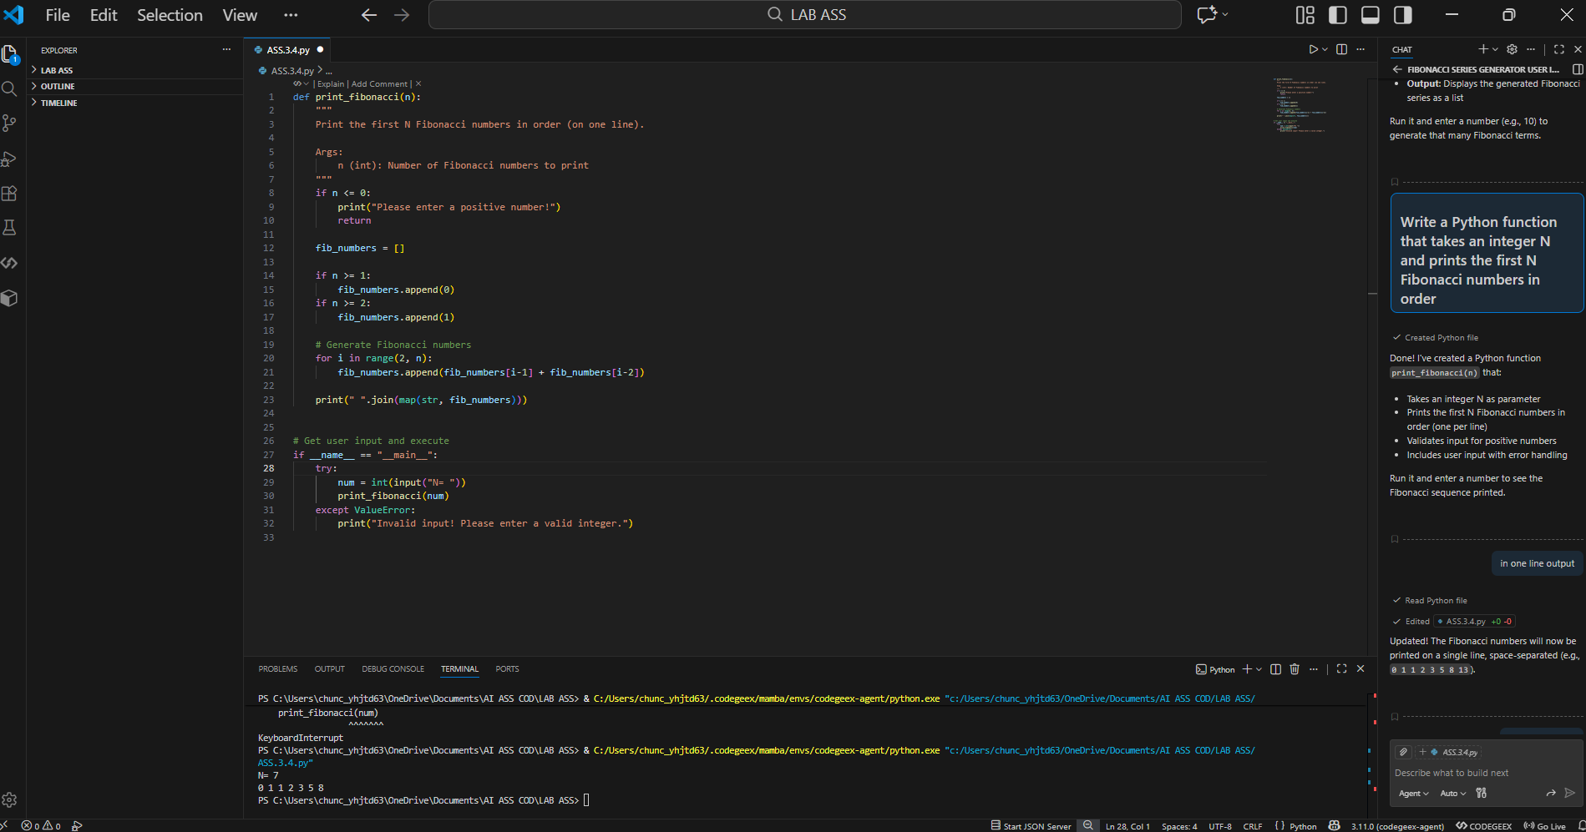

Task 2: One-shot Prompt – List Reversal Function
Task Description #2
• Write a comment prompt to reverse a list and provide one
example below the comment to guide Copilot.
Prompt: # Write a Python function that takes a list as input and returns the list in reverse order
Code and output :

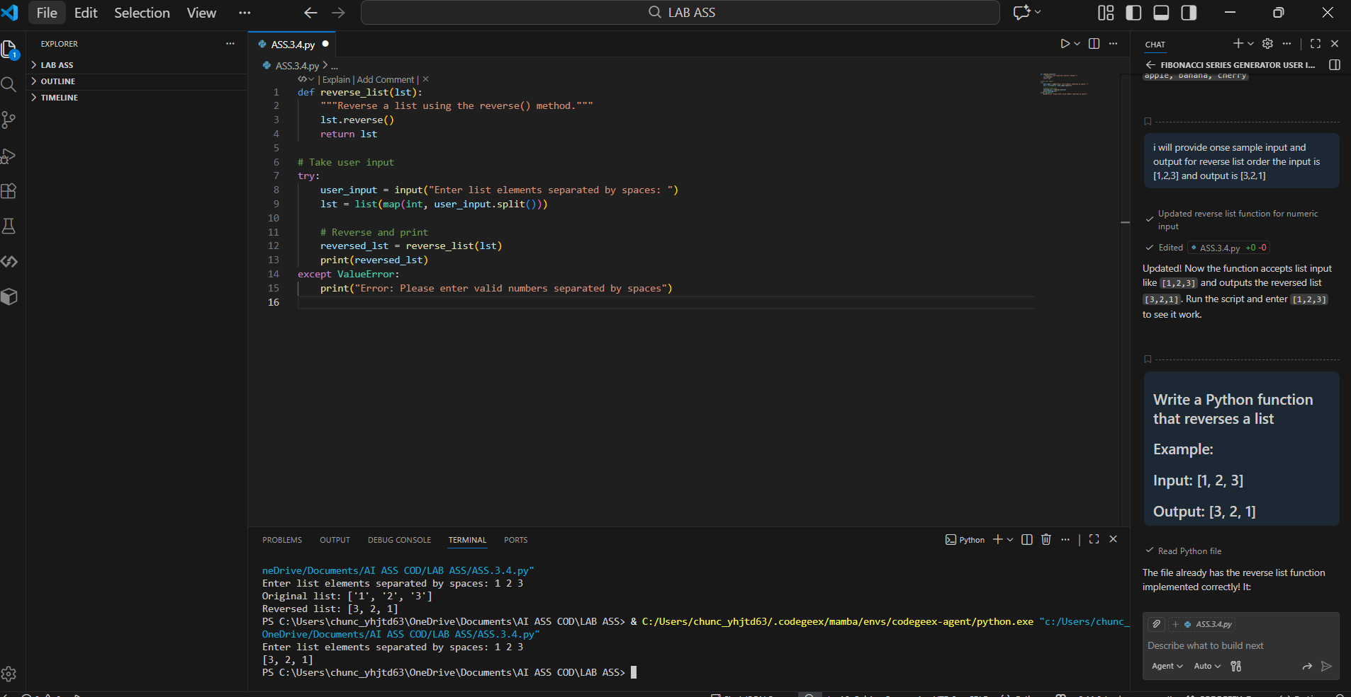

Task 3: Few-shot Prompt – String Pattern Matching

Task Description #3
• Write a comment with 2–3 examples to help Copilot understand
how to check if a string starts with a capital letter and ends with a period.

Prompt: # Write a Python function is_valid() that checks whether a string starts with a capital letter
# and ends with a period (.)

Code and output :
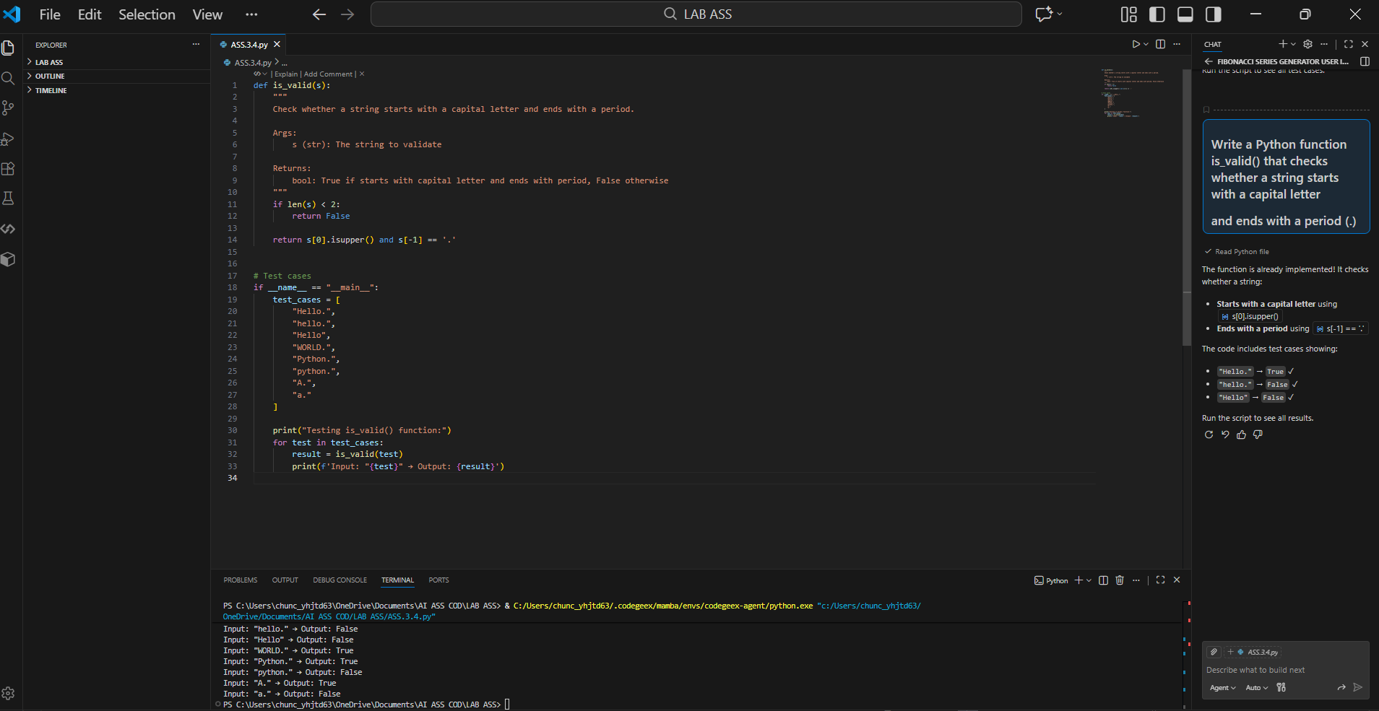

Task 4: Zero-shot vs Few-shot – Email Validator

Task Description #4
• First, prompt Copilot to write an email validation function using
zero-shot (just the task in comment).
• Then, rewrite the prompt using few-shot examples.
Prompt: # Write a Python function that validates whether a given string is a valid email address
# Write a Python function that validates whether a given string is a valid email address
# Examples:
# Input: "user@example.com" → Output: True
# Input: "userexample.com" → Output: False
# Input: "user@com" → Output: False

Code and output :

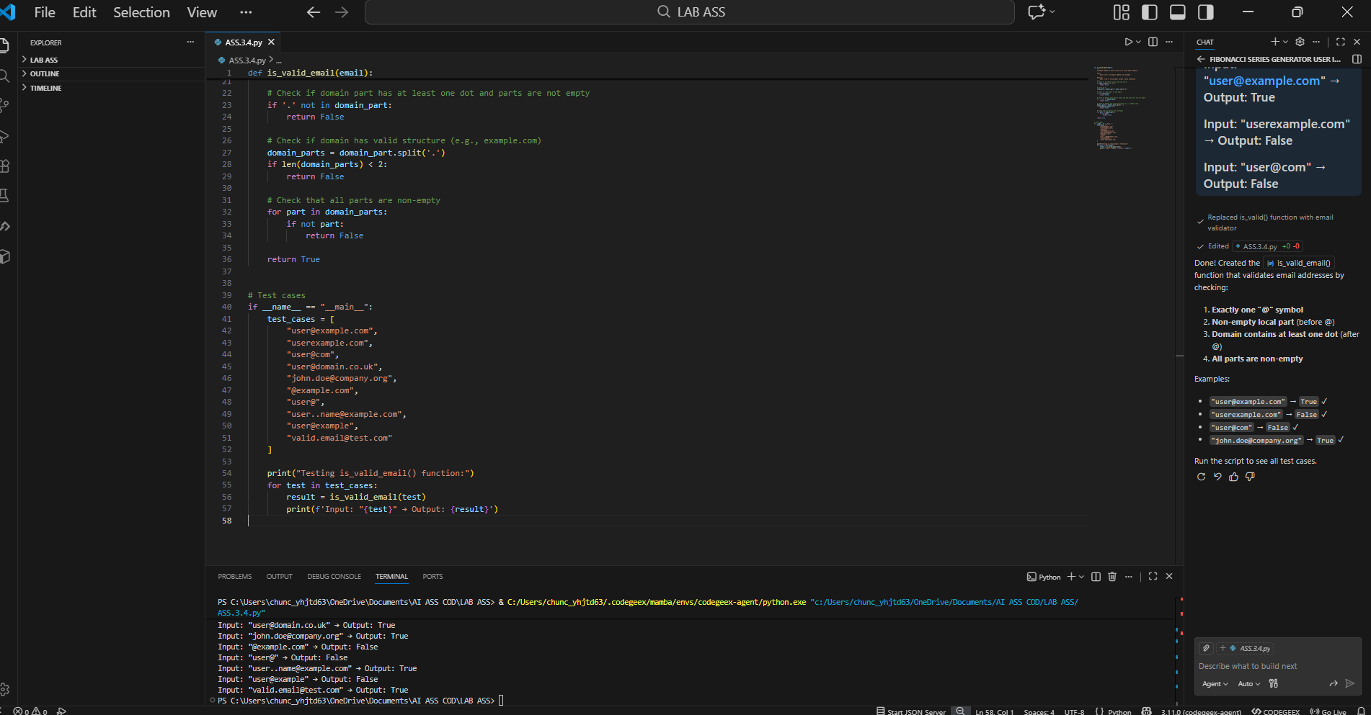

Task 5: Prompt Tuning – Summing Digits of a Number

Task Description #5
• Experiment with 2 different prompt styles to generate a function
that returns the sum of digits of a number.
Style 1: Generic task prompt
Style 2: Task + Input/Output example

Prompt:
1) # Write a Python function that returns the sum of digits of a given number
2)# Write a Python function that returns the sum of digits of a number
# Example:
# Input: 123 → Output: 6
Code and output :
